Design and Tuning Methodology
Flow Controllers with Parallel Control Valves as the Final Control Element

Trevor Slade

Introduction

Many of the flow controllers used on TAPS send their control output to two parallel control valves while regulating flow within their control region as illustrated in figure 1 below:

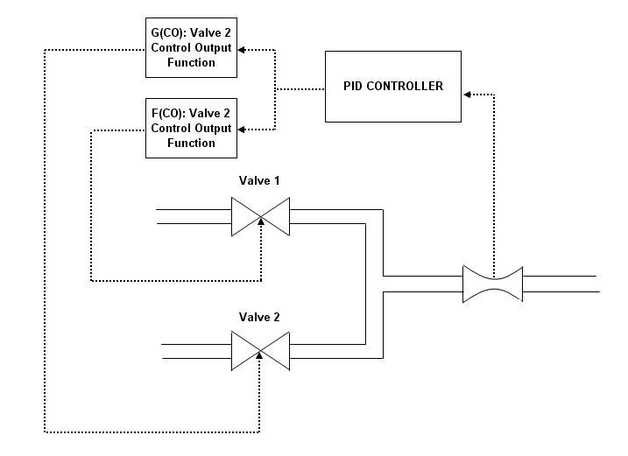
Figure 1: Block Flow Diagram of Parallel Flow Control Valve Control Scheme

These controllers are typically configured so that if the flow were to go from 0-100% than the smaller control valve (valve 1) opens and the larger control valve (valve 2) remains closed until valve 1 reaches 100% open at which point valve 2 opens up and continues to travel until it is fully open.
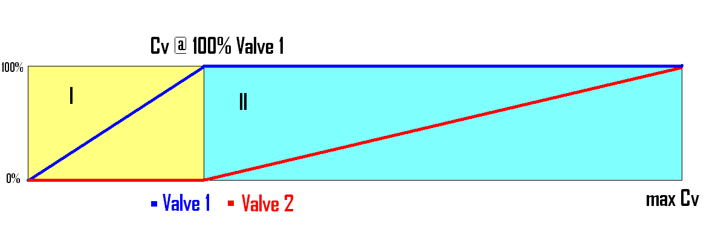
Figure 2: Diagram Representing the Typical Parallel Control Valve Opening sequence
Region 1: Valve 2 is 0% Open and the controller is actively controlling Valve 1
Region 2: Valve 1 is 100% open and the controller is actively controlling Valve 2

This sequence can result in poor control when the controller’s final control element switches between being valve 1 and valve 2 because valve 1 is starting to top out when it relinquishes control to valve 2 which will have to come off of the valve seat. This is compounded by the fact that the flow coefficient curves for valve 1 and valve 2 are usually drastically different. This paper provides a description of a suggested controller design and tuning methodology to create a flow controller that can smoothly operate parallel control valves.

Valve Sequencing

Rather than use the typical valve sequence it is suggested that the following sequence be used: if the flow were to go from 0-100% than valve 1 would first start to open while valve 2 remains closed until valve 1 reaches 50% open at which point valve 2 starts to open while valve 1 remains 50% open. After valve 2 is fully open valve 1 will resume traveling until it too is fully open.

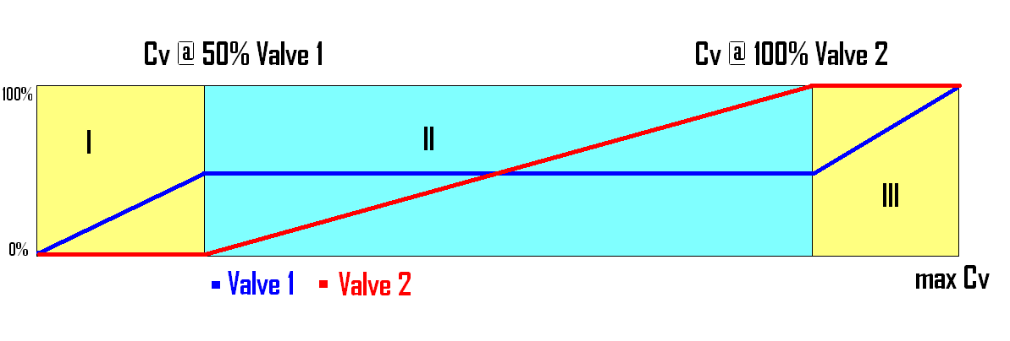
Figure 3: Diagram Representing the New Approach
Region 1: Valve 2 is 0% Open and the controller is actively controlling Valve 1
Region 2: Valve 1 is 50% Open and the controller is actively controlling Valve 2
Region 3: Valve 2 is 100% Open and the controller is actively controlling Valve 1

This will result in a valve sequence where valve 1 will always be in its optimal control range when it is passing control to valve 2 providing a smoother transition.

Creating a Linear Steady State Flow Response

This sequence creates three separate control regions; Region 1 is where the flow controller is actively controlling valve 1 while valve 2 is fully closed, Region 2 is where the flow controller is actively controlling valve 2 while valve 1 is 50% open and Region 3 is where the flow controller is actively controlling valve 1 while valve 2 is 100% open. One of the issues encountered when switching control between two control valves is the change in dynamic response. This sections presents a controller design methodology that will neutralize the effect of the change in steady state response over the control region.
A control valve’s steady state flow response is given by equation 1:

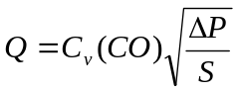
Equation 1

It is convenient to define the process variable as the flow rate normalized by the maximum flow rate which corresponds to fully opening valve 1 and valve 2 at the highest differential pressure and lowest density. An expression for the process variable is given in equation 2.

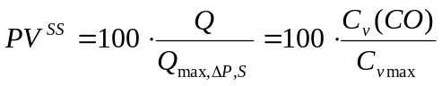
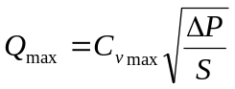
Equation 2

If the change in density is negligible it is convenient to simplify this expression as shown in equation 3.

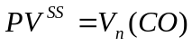
Equation 2

One way to maintain a linear steady state control response is to manipulate the controllers output with a polynomial function that is the inverse of V (CO). This process is illustrated below:

For any function, 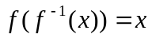
Define, 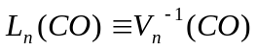
Define, 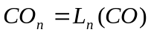
Then, 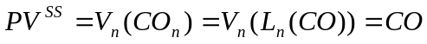
Tuning Valve 1 and 2 Control Output Functions

To apply this theory the following steps can be taken to tune the control output functions.

List of Variables

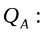 Steady State Flow Rate When Valve 1 is 50% Open and Valve 2 is Fully Closed
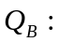 Steady State Flow Rate When Valve 1 is 50% Open and Valve 2 is 100% Open
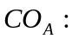 Controller Output When Valve 1 is 50% Open and Valve 2 is Fully Closed
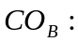 Controller Output When Valve 1 is 50% Open and Valve 2 is 100% Open
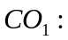 Control Output to Valve 1
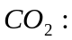 Control Output to Valve 2

Note: during this testing the controller will be in manual

- Set 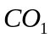 to 50%

  - Record 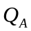 ______________

  - Record 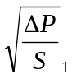_____________

- Keep 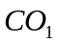 at 50% and Set 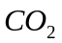 to 100%

  - Record 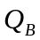 ______________

  - Record 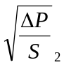_____________

- Keep 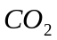 at 100% and Set to 100%

  - Record 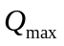 ______________

  - Record 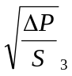_____________

Perform the following calculations:

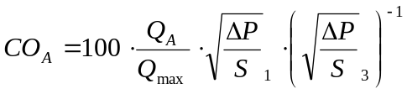

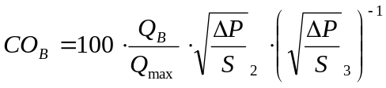

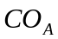 and 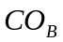are the control outputs where control is swapped between valve 1 and valve 2. With this information calculated the boundaries of the function blocks are known.

Table 1: Layout of Current Information
CO
0% | 0% | 0%
 | 50% | 0%
 | 50% | 100%
100% | 100% | 100%

The next step is to collect information that will be used to both estimates 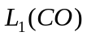, 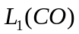and 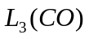 and estimate the dynamics of the process. 3 sets of step tests will be performed for each section of the control region. Although there are many ways to collect this information the following is offered as an example:

Note 1: Data should be collected as quickly as possible using data historian software

Region 1

Note 2: during this testing the controller will be in manual

- Set 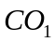 and to 0%
- Step up to 12.5% and wait for the process variable to settle
- Step up to 25% and wait for the process variable to settle
- Step up to 37.5% and wait for the process variable to settle
- Step up to 50% and wait for the process variable to settle

Region 2

- Step up to 12.5% and wait for the process variable to settle
- Step up to 25% and wait for the process variable to settle
- Step up to 37.5% and wait for the process variable to settle
- Step up to 50% and wait for the process variable to settle
- Step up to 62.5% and wait for the process variable to settle
- Step up to 75% and wait for the process variable to settle
- Step up to 87.5% and wait for the process variable to settle
- Step up to 100% and wait for the process variable to settle

Region 3

- Step up to 62.5% and wait for the process variable to settle
- Step up to 75% and wait for the process variable to settle
- Step up to 87.5% and wait for the process variable to settle
- Step up to 100% and wait for the process variable to settle

Use graphical or numerical methods to use this data to estimate , and .

